Project Design Phase

Solution Architecture
Date | 29 October 2026
Team ID | althafbonala@gmail.com
Project Name | iMovies Application
Maximum Marks | 4 Marks

Architecture Overview
The iMovies Application uses a layered MERN architecture. The frontend presents the user interface; the Express backend validates requests and applies application rules; Mongoose connects the backend to the local MongoDB database.
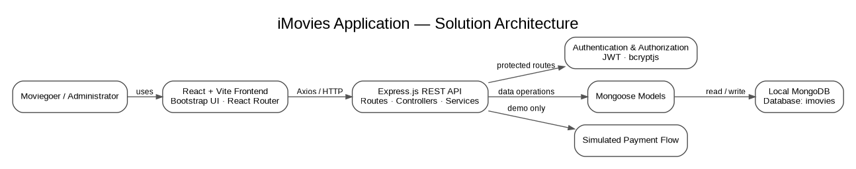

Main Components
Layer | Components | Responsibility
Presentation | React, Vite, Bootstrap, React Router, Axios | Render the movie catalogue, booking flow, user views, and admin views; call backend APIs.
Application/API | Node.js, Express, routes, controllers/services | Validate requests, apply booking and access-control rules, and return API responses.
Security | JWT, bcryptjs, role-based middleware | Authenticate users, hash passwords, and restrict administrative actions.
Data access | Mongoose models | Read and update application records through the data layer.
Persistence | Local MongoDB database: imovies | Store users, movies, theatres, showtimes, bookings, reviews, and watchlist-related data.
Payment | Simulated demo payment flow | Demonstrate success/failure/cancel outcomes; no real gateway is integrated.

Key Flows
• Authentication: frontend → auth API → controller/model → users data.
• Discovery: frontend → movie/theatre/showtime APIs → data layer → catalogue results.
• Booking: frontend → booking API → server-side seat and price validation → booking/showtime data → booking/ticket response.
• Administration: protected admin API → movie/theatre/showtime management → persisted updates.

